
Story

Date | 28 August 2026
Team ID | ____________
Project Name | AI Adoption and Impact in Global Education
Maximum Marks | 5 Marks

By using stories in Tableau, you can effectively communicate complex data in a way that is both interactive and engaging, making it easier for the audience to follow along and understand the insights. It’s a tool for data storytelling, allowing you to present insights in a cohesive, engaging way that takes viewers through a logical progression of findings or analyses.
In Tableau, Story is a feature that allows you to create a sequence of dashboards, visualizations, and text to present data insights in a cohesive and narrative-driven way. It's like a slideshow within Tableau that guides the audience through a series of data points, helping them understand key insights, trends, or outcomes of your analysis.

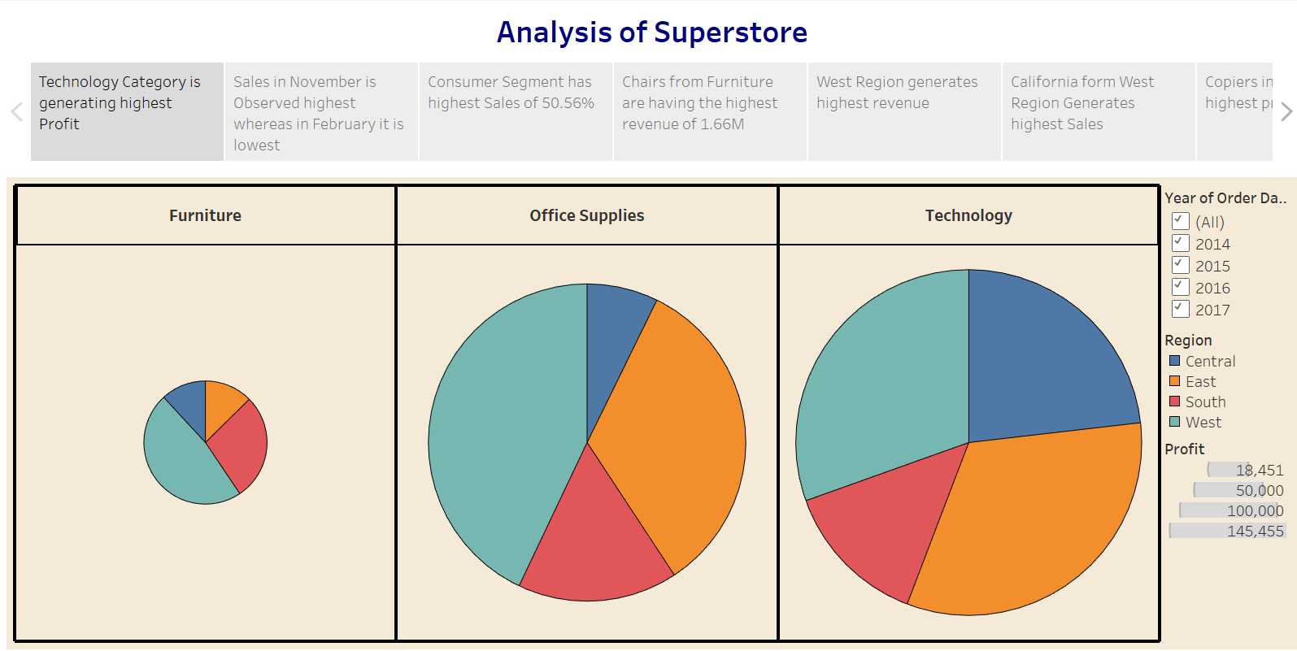

Story: Global AI Adoption in Education
The Tableau story will guide the audience from the overall global picture of AI adoption to regional and demographic differences, then to infrastructure and policy-related patterns. The sequence is designed to communicate findings in a logical progression, following the template's purpose of using Tableau Story to present dashboards, visualizations, and text as a cohesive narrative.
Story Point 1 – Global AI Adoption Overview
Begin with an overview dashboard showing the major AI adoption indicators for students, teachers, and schools. Use KPI cards, a country/region map, and summary charts to establish the overall state of AI integration in education.
Story Point 2 – Regional and Country Differences
Move from the global overview to country and regional comparisons. Highlight regions with relatively higher or lower adoption and allow users to filter or drill down to individual countries where the dataset supports it.
Story Point 3 – Student and Teacher Adoption
Compare student and teacher AI adoption to identify differences between the two groups. This view helps explain whether AI integration is progressing similarly among learners and educators.
Story Point 4 – AI Tools and Usage Patterns
Analyze which AI tools are being used and how daily AI usage time varies across regions or user groups. This stage provides insight into AI tool preferences and usage intensity.
Story Point 5 – Infrastructure and Education Indicators
Examine AI adoption alongside internet penetration and education index values. Scatter plots and comparative visuals can be used to identify patterns between digital infrastructure, education development, and AI adoption.
Story Point 6 – Government Policy and Adoption
Compare government AI policy indicators with adoption levels where policy data is available. The objective is to identify patterns that may help stakeholders understand different policy environments and their relationship with AI integration.
Story Point 7 – Demographic and Equity Gaps
Conclude the analysis by examining demographic and regional differences. Highlight potential adoption gaps and areas where unequal access or implementation may require additional attention.
Observations
• AI adoption should be compared across students, teachers, schools, countries, and regions to identify differences in educational AI integration.
• Regional and country-level comparisons can reveal areas with relatively higher or lower adoption and help identify potential adoption gaps.
• Differences in AI tool usage and daily usage time can provide insight into how intensively educational AI is being used.
• Comparing AI adoption with internet penetration and education index can help identify patterns between infrastructure, education development, and AI integration.
• Government policy indicators can provide additional context for understanding differences in AI adoption environments across countries.
• Demographic analysis can help identify potential inequalities and support discussion of more equitable AI integration.
Activity 2
Publish the completed Tableau Story on Tableau Public and paste the public link below.
Tableau Public Story Link: https://public.tableau.com/views/ProjectDashboard_17874360763640/Story1?:embed=y&:sid=&:redirect=auth&:display_count=n&:origin=viz_share_link
Story Screenshot(s): 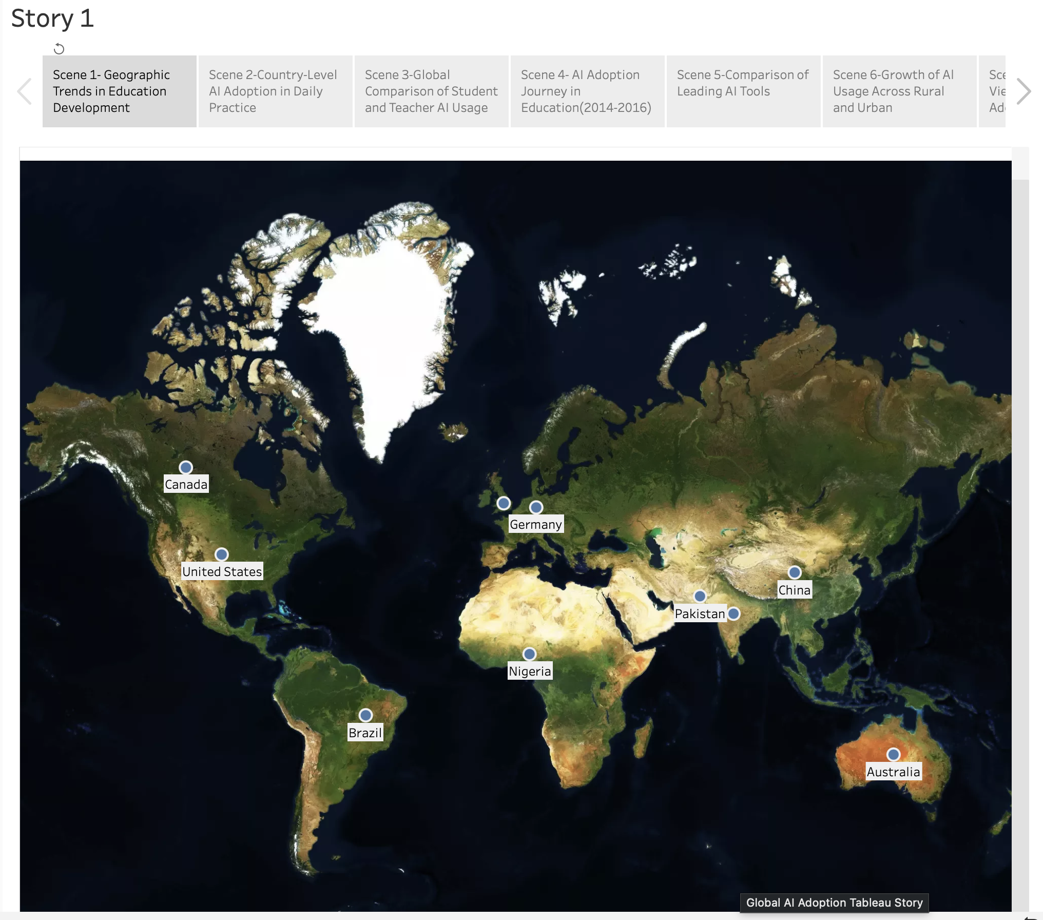
Note: The observations above describe the intended analysis based on the project scope. Exact numerical findings should be added after the final Tableau dashboards are completed.

